# **Supplier EMAIL TOOL INSRUCTIONS**

1. Open the **supplier_send_list.xlsx** file in the same folder as the code (**DO NOT RENAME THIS FILE**).
2. Add the supplier numbers you want to send (NO leading zeroes) in Column A. **Duplicate supplier numbers will be ignored** by the code. *Column B to J are filled out by the code automatically.*

**NOTE:** If you copy and paste – you must right click, paste supplier numbers as values.

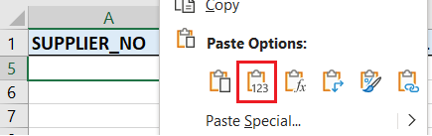

1. Save and close the *supplier_send_list.xlsx* file
2. Add file attachment you want to this folder (EACH FILE MUST BE UNDER 2MB). If your file name format looks like: *20002334_myfilename* – the code will determine it’s unique for each supplier. **If you want each supplier to get the SAME attachment DO NOT NAME YOUR FILE STARTING WITH NUMBERS.**



1. Open the **SMTP_launcher.py**

**NOTE:** you must be on VPN, and have access to SQL SERVER and SNOWFLAKE

1. Select the roles you want to send to, enter your message and subject



1. Click *SEND*.

**NOTE:** Any supplier number with SENT_STATUS equal to *SENT* in *supplier_send_list.xlsx* will be ignored by the code in **LIVE MODE** when retrying to send failed emails.

**NOTE:** This field is **OPTIONAL**. If you fill it out, all emails will be sent from the typed email address instead of the SPA aligned to supplier



1. Check if any emails failed in status bar – open the *supplier_send_list.xlsx* file to see why it failed.



# **MESSAGE VARIABLES**

You can type in variables (CASE SENSITIVE) in your email message or subject to have the code fetch the corresponding information tied to that variable.

[SUPPLIER_NAME] -> supplier name

[SUPPLIER_NUMBER] -> supplier number

[SPA_NAME] -> spa name aligned to supplier

[SPA_TITLE] -> spa title aligned to supplier

[SPA_EMAIL] -> spa email aligned to supplier

**EXAMPLE 1.**



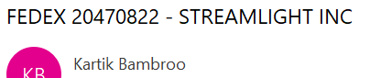

**EXAMPLE 2.**

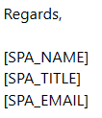 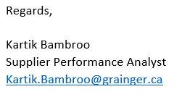

# **HTML FORMATTING**

You can place your text inside a HTML tag to have the desired format.

<b></b> -> bold

<u></u> -> underline

<i></i> -> italics

<li></li> -> bullet point

<h1></h1> -> extra-large header

<h2></h2> -> large header

<h3></h3> -> medium header

<h4></h4> -> small header

<h5></h5> -> extra-small header

<a href=""></a> -> hyperlink

[[Click here for a more comprehensive list of tags]](https://www.w3schools.com/tags/ref_byfunc.asp)

**EXAMPLE 1.**

**<b>**THIS TEXT IS BOLD**</b>**  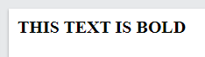

**EXAMPLE 2.**

**<u><b>**THIS TEXT IS BOLD AND UNDERLINED**</b></u>** 

**EXAMPLE 3.**

**<a href="**https://www.google.com**">**What the reader sees**</a>** 

# **PROGRAM ERRORS**



The *supplier_send_list.xlsx* is opened and needs to be closed.



The supplier number format is incorrect, refer to step 3. You might have also pasted non-number values.



The code cannot find one valid supplier to do a test because all the supplier numbers have at least one error. Open *supplier_send_list.xlsx* to see what is causing the errors.



You must select at least one role to send to.

# **EMAIL ERRORS**



CONTACT_ERROR

* **MISSING CONTACT FIELD(S):** The code cannot find complete information from the SQL server tables. The SQL code used to fetch the contact can be found in DEVELOPER_FILES folder -> *contact_query.sql*

FILE_ERROR

* **MISSING FILE:** the code cannot find the unique file associated with that supplier in the ATTACHMENT folder.
* **ATTACHMENT FILE IN USE:** the attachment file is currently opened and needs to be closed before sending

SERVER_ERROR

* **NO SERVER RESPONSE:** The server returned empty response. This could be caused by invalid characters in your body text such as weird quotes, French characters, etc. It’s difficult to see since characters like quotation has 3 different variations and only one of them works. This can be prevented by AVOID copying text from outlook emails.

**If you still face this error with ALL supplier numbers**, [you need to get local admin rights](https://gprod.service-now.com/wwg?id=sc_cat_item&table=sc_cat_item&sys_id=5c5244c71bbc1054c998a6c8ec4bcb80&searchTerm=admin%20right):

Then Open command prompt

Type **python** and press ENTER

Type **import certifi** and press ENTER

Type **print(certifi.where())** and press ENTER

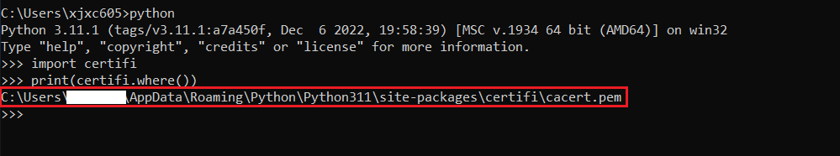

Then press windows key, search **PowerShell** -> Right click **Run as administrator**

**Replace "**put_your_path_here_keep_the_quotes**"** with what you had circled in red in previous step – **KEEP THE QUOTES**

**$certifi = "**put_your_path_here_keep_the_quotes**"**

Then press ENTER.

Then paste the bellow command and press ENTER.

**[System.Environment]::SetEnvironmentVariable("**REQUESTS_CA_BUNDLE**",** $certifi**)**

* **INCORRECT EMAIL ADDRESSES:** At least one of the From, To or CC email addresses are not in the correct format of [*something@domain.com*](mailto:something@domain.com)
* **EXCEED SIZE LIMIT:** with larger files, the server can overload and skip some of the emails. But if at least one of the emails are sent successfully, you can resend the failed ones
* **OTHER SERVER ERROR:** server ran into unknown error – can try to resend
* **CHECK SERVER_RESPONSE:** server did not respond in time, go check **column (J)** to verify sent status. If you see the same text in the **expanded formula bar**, it means it’s sent. Go update **column (B)** to SENT

